Naturfreunde Logo 2001

Farbdefinition

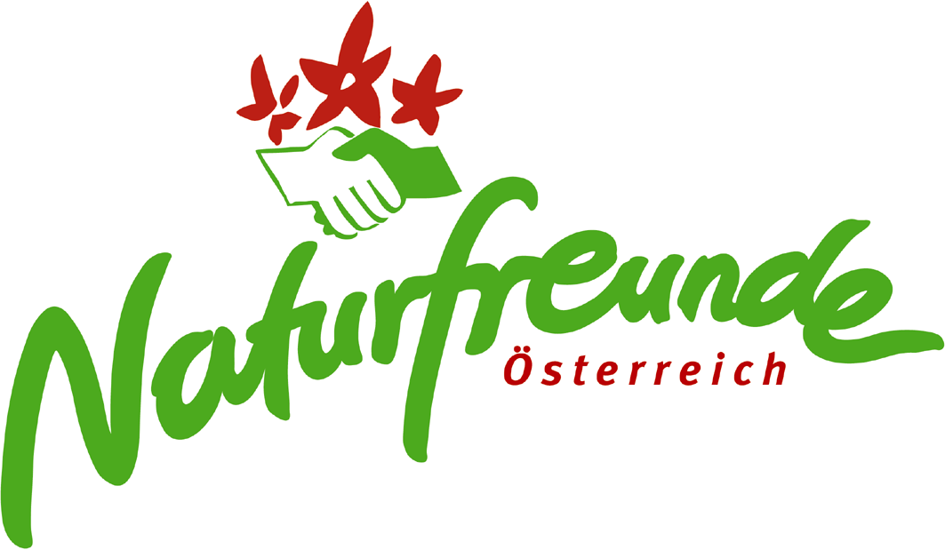

Rot
Schmuckfarbe Pantone: Red 032

Euroskala CMYK: Cyan 0%, Magenta 91%, Yellow 87%, K 0%

Grün
Schmuckfarbe Pantone: 361

Euroskala CMYK: Cyan 76%, Magenta 0%, Yellow 91%, K 0%

